1.Write a hive query find the average age of male and female persons died in the titanic tragedy

Here the creation of table and data is loaded then the select statement is implemented to get the columns gender and the Count. For this we have grouped based on the gender and the condition is implemented using where clause.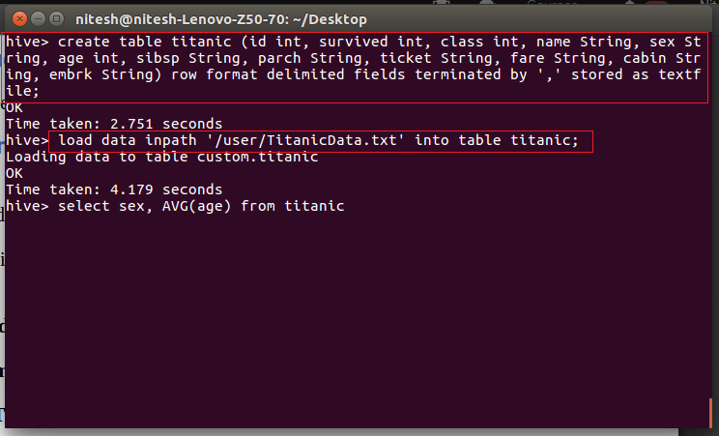



Here in this code we have grouped by the gender and we need the count of male, female died in the tragedy for this we have used a where clause and group by clause.

2.Write a hive query to find the number of people died and survived in each class

Here we need the number of people died as well as survived in each class so we have grouped by class and the died/survived column. For this query we have utilized count function and where clause and group by clause.

